Contents
2.3B Overseas Support – Comparable Contract Evidence 2
Broader evidence rather than isolated success stories 2
The work completed overseas 3
Mixed-equipment capability 4
Territory context 5
Nepal – frequent preventative maintenance and no separate breakdown call-outs 5
How the evidence strengthens the proposed contract 6

2.3B Overseas Support – Comparable Contract Evidence
Tender Question: Provide evidence that the Bidder can continually and consistently meet contracted lead times and deliver the overseas service provision throughout the life of the contract.
Scoring Focus: One contract within the last two years comparable in size, scope and type, highlighting achieved overseas performance.

COMPARABLE EVIDENCE BASE: Pulse Fitness’s recent MOD overseas activity demonstrates location-based engineering, direct UK deployment, mixed-brand diagnosis and repair, planned service, parts follow-on and high-frequency preventative maintenance. All quantified evidence uses the aligned period 1 August 2024 to 31 July 2026.

6 | 113 | 136 | 249
territories evidenced | case-managed requirements | Nepal PPM reports | records reviewed

Broader evidence rather than isolated success stories
The submission deliberately uses the full recent evidence base instead of selecting three favourable jobs. Response statistics are calculated from 113 case-managed requirements with a populated response value across Cyprus, the Falkland Islands, Brunei, Gibraltar and Kenya. Nepal is presented separately because its evidence consists of frequent planned maintenance reports rather than reactive call timestamps.
The combined recorded average is 3.33 days, and the median is four days. Within the case-managed population, 49.6% of responses were recorded within three days, 90.3% within four days, 98.2% within five days and every recorded response within six days. These are described as recorded response days because the historic source field does not independently define every contractual clock start, stop and exclusion rule.
The five territories represent materially different delivery conditions: established local routes, a remote South Atlantic location and direct UK deployment where a resident route is not used. The fact that the performance is presented by territory—rather than hidden within one blended claim—allows the evaluator to see the real operating context.
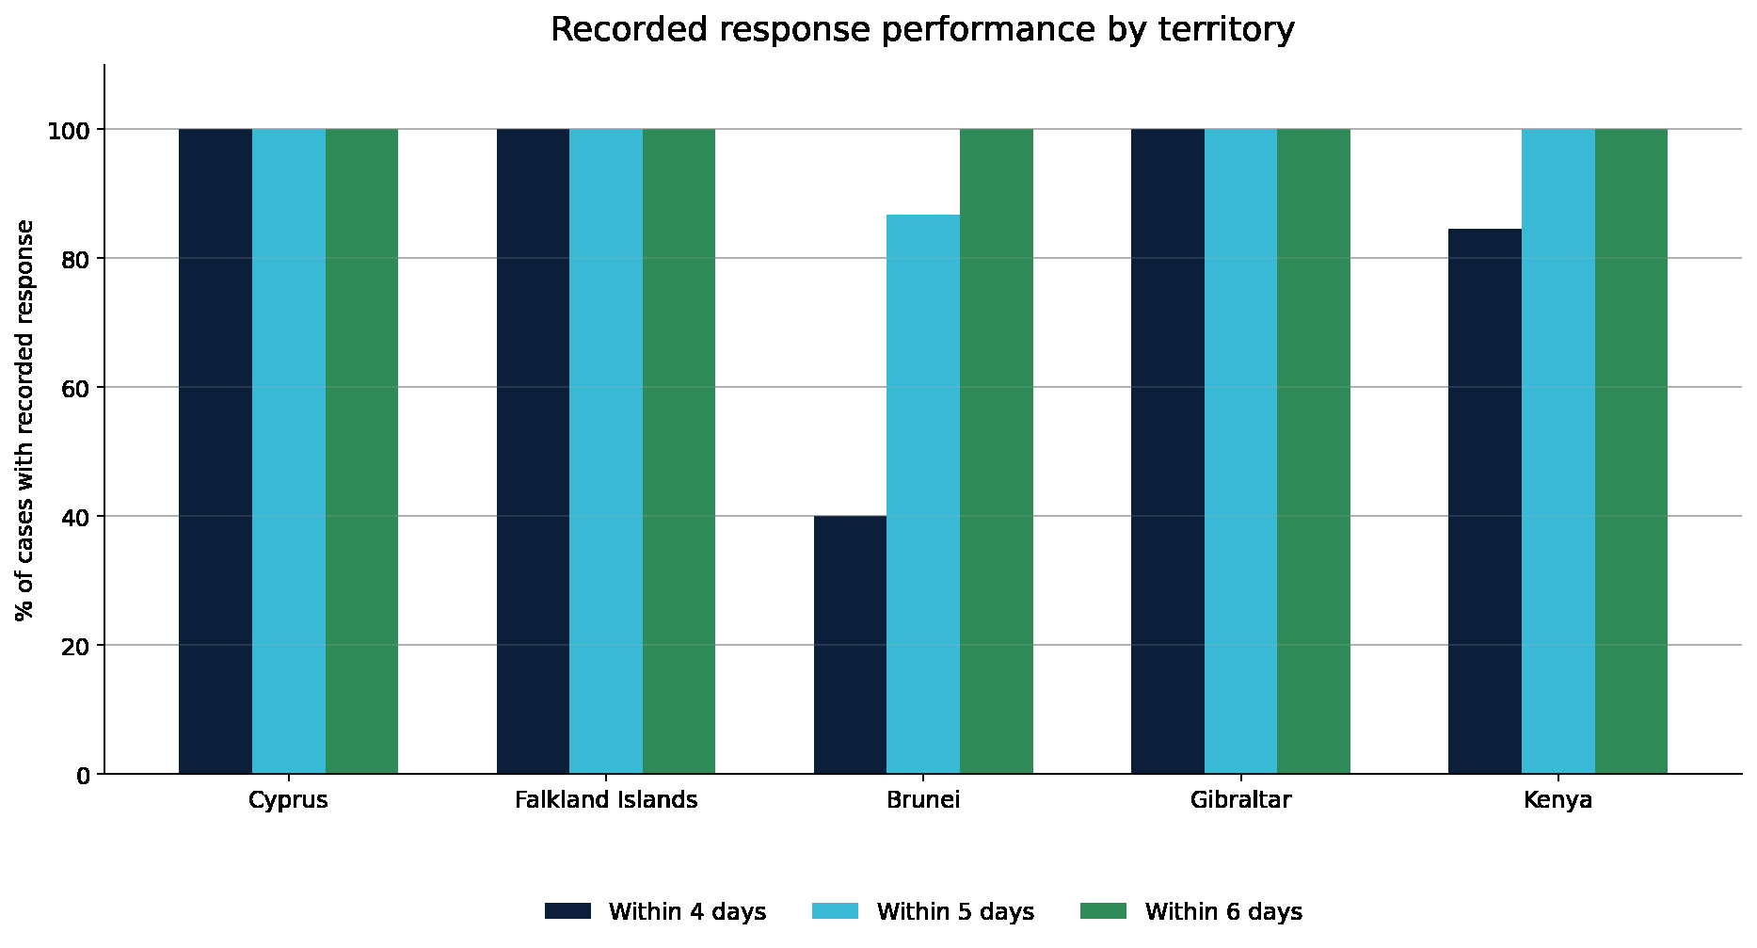
Figure 1 – Recorded overseas response performance by territory.
What the figure shows: The chart compares the proportion of cases within four, five and six days for Cyprus, the Falkland Islands, Brunei, Gibraltar and Kenya.
Why it matters to the MOD: The figure demonstrates consistent delivery across different support routes. It also shows the effect of direct deployment in Brunei without disguising that difference inside a single unsupported SLA claim.
Territory | Cases | Average | Median | Recorded threshold position
Cyprus | 30 | 3.27 days | 3 days | 100% within four days
Falkland Islands | 41 | 3.17 days | 4 days | 100% within four days
Brunei | 15 | 4.20 days | 5 days | 40% within four; 100% within six days
Gibraltar | 14 | 2.86 days | 3 days | 100% within four days
Kenya | 13 | 3.46 days | 3 days | 84.6% within four; 100% within five days

The work completed overseas
The records show much more than attendance. They demonstrate the practical work carried out by location-based and directly deployed engineers across planned inspection, diagnosis, mechanical and electronic repair, assembly, component replacement and controlled follow-on. One requirement can include several work themes, so the categories overlap rather than being forced into a single label.
Mechanical repair and adjustment appear in 68 case records and includes bearings, cables, pulleys, pedals, cranks, ropes, fasteners, alignment, calibration and lubrication. Bike, rower and functional-equipment activity appear in 62 records, while parts replacement or controlled follow-on appears in 60. Treadmill and drive-system work appear in 42 records. Electronic, console and sensor diagnosis appears in 37 records, and the same number contain diagnosis, condition, safety or advisory activity.
This breakdown demonstrates that Pulse Fitness is not relying on overseas partners solely for simple visual inspections. The evidence includes technical diagnosis, major component identification, mixed-brand repairs and the control of work that cannot safely be completed on the initial attendance.
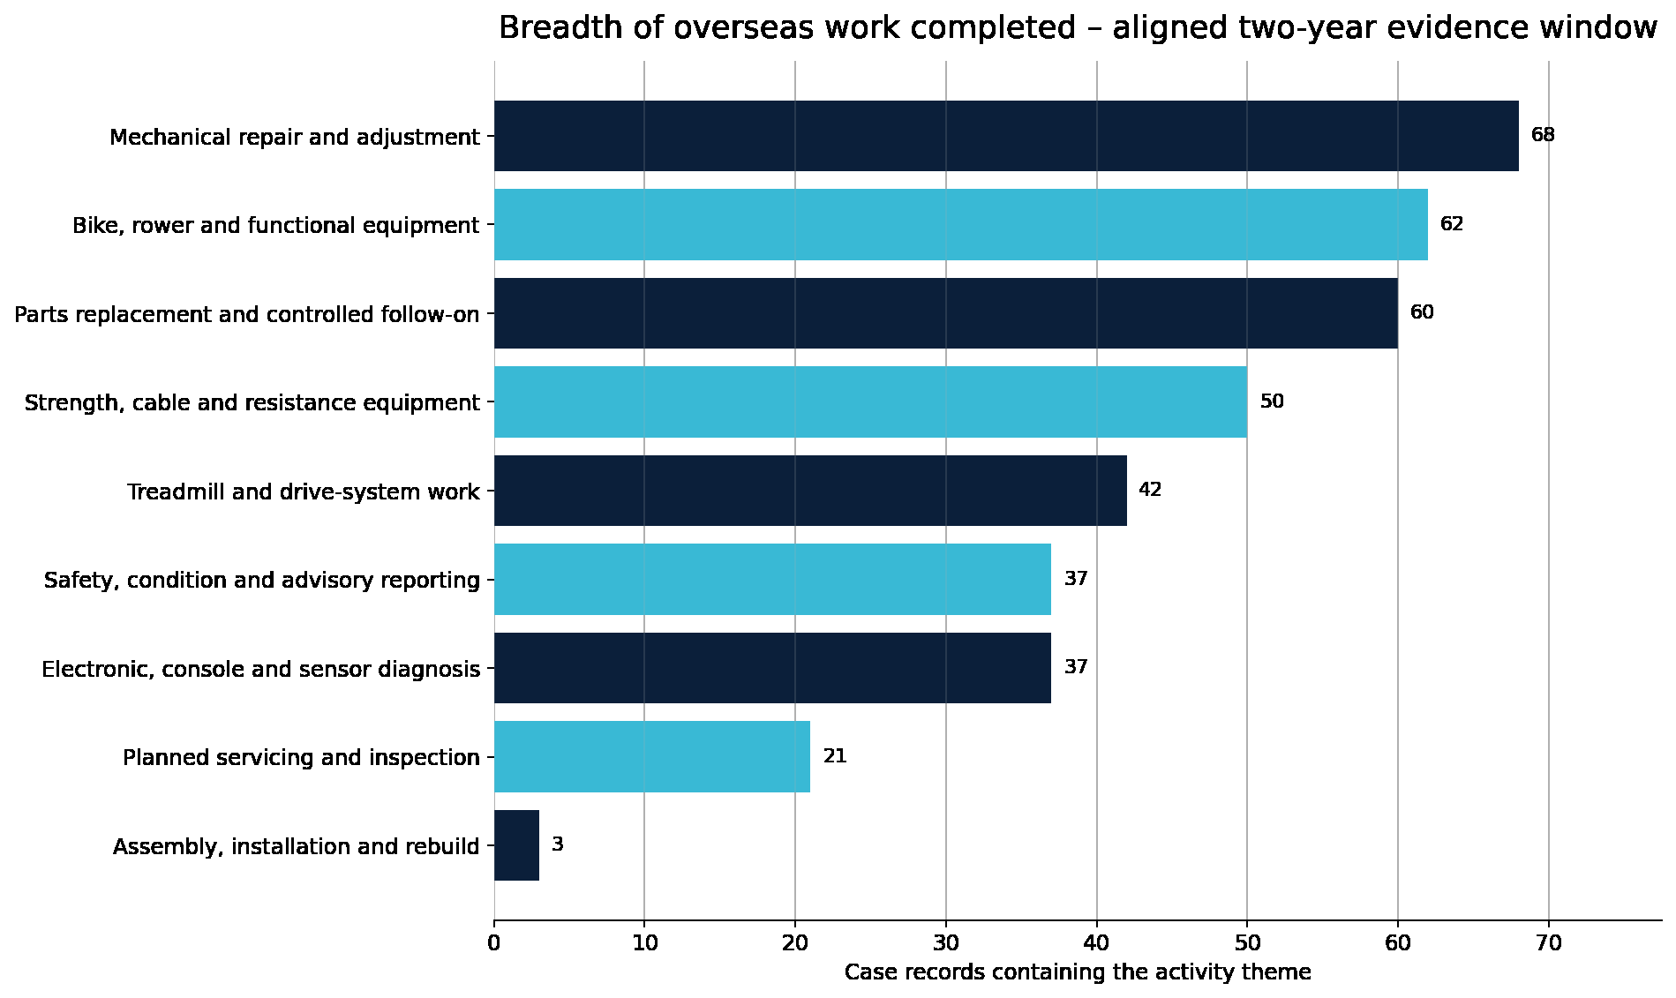
Figure 2 – Breadth of overseas work completed.
What the figure shows: The chart counts case records containing each work theme, including mechanical repair, bikes and rowers, parts follow-on, strength and cable work, treadmills, servicing, electronic diagnosis and assembly.
Why it matters to the MOD: The breadth shows the practical competence required to maintain a live overseas estate. It also supports the proposed combination of local engineering, Congleton technical support and central parts control.

Mixed-equipment capability
The evidence covers cardiovascular, functional and strength equipment from Pulse Fitness and major third-party manufacturers. Recorded work includes treadmills and runners, Wattbikes and other cycles, Concept2 rowers and SkiErgs, selectorised and plate-loaded strength equipment, cable stations, consoles, displays, sensors and smaller functional-training components.
This is directly relevant to the MOD estate. Overseas facilities are not single-manufacturer environments, and the most effective engineer must work from the installed equipment and actual fault rather than a restricted product catalogue. Pulse Fitness’s training, technical escalation and parts model has been built around that reality.
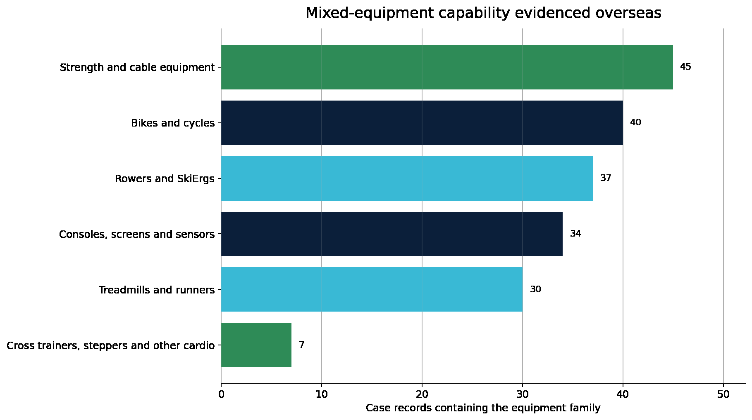
Figure 3 – Mixed-equipment capability evidenced overseas.
What the figure shows: The chart shows the number of case records containing strength/cable equipment, bikes and cycles, rowers and SkiErgs, consoles and sensors, treadmills and runners and smaller functional items.
Why it matters to the MOD: The distribution demonstrates capability across the full gym environment and supports the Authority’s need for one service route covering Pulse and third-party equipment.

Territory context
Cyprus provides an established location-based route across planned service and mixed-brand repair, with every recorded response in the aligned period within four days. Gibraltar demonstrates named resident continuity across planned Type A and reactive work, also with every recorded response within four days. Kenya provides a consistent BATUK route across planned service, diagnosis and repair, with all recorded responses within five days.
The Falkland Islands demonstrate sustained local support in a remote environment where practical continuity and parts follow-on are essential. Every populated recorded response in the aligned period falls within four days. Brunei demonstrates the direct-deployment model and controlled major-component follow-on; all recorded responses fall within six days. These differences support the route-selection process proposed in the delivery plan.

Nepal – frequent preventative maintenance and no separate breakdown callouts
136 | 1,964+ | ~Weekly | 99.3%
planned-maintenance visits | asset-level actions recorded | attendance cadence (7-day median) | assets recorded Good

The Nepal evidence covers British Gurkhas Nepal facilities at Kathmandu and Pokhara from December 2024 to May 2026. It records frequent local preventative maintenance, including inspection, operational testing, adjustment, cleaning, lubrication, safety verification and electrical or resistance checks across the estate. The programme is evidenced by more than 130 dated job sheets covering both British Gurkha camps — Kathmandu and Pokhara — on an approximately weekly cycle, each recording the machines attended, the checks completed and the next scheduled maintenance date.
No separate reactive breakdown callouts were identified in the supplied Nepal evidence. The correct interpretation is not that maintenance was unnecessary; it is that approximately weekly attendance allowed emerging issues to be identified and managed during planned visits before they developed into a wider pattern of breakdowns. Of the quantified asset actions, 99.3% were recorded Good.
The two replacement-required entries related to the same treadmill rear roller cap. Subsequent records returned the asset to good condition. Nepal is therefore used as evidence of sustained proactive maintenance and equipment availability, not as a reactive response KPI.
WHY THE EVIDENCE IS COMPARABLE: The aligned two-year records show six territories, three distinct support models, a broad mixed-equipment workload, controlled parts follow-on and a high-frequency preventative-maintenance route. They demonstrate that Pulse Fitness can sustain overseas support under one central commercial, technical and evidence structure.

How the evidence strengthens the proposed contract
The overseas history has shaped the final plan. Local continuity in Cyprus, Gibraltar, Kenya and the Falkland Islands supports the vetted dealer-network approach. Brunei supports direct UK deployment where local capability is not the right answer. Nepal demonstrates the value of regular planned attendance. The work-type and equipment breakdown supports the investment in remote triage, Congleton technical support, parts planning and a full overseas MODService record.
Pulse Fitness is not asking the evaluator to infer global capability from a map. The recent records show actual service, repair and maintenance activity across multiple territories and delivery routes, with transparent response reporting and clear evidence of the work undertaken. That experience provides a lower-risk foundation for the full global reach required by LSL/DC/0223.

Comparable Contract — overseas element
The comparable contract is the overseas element of the MOD Physical Training Equipment service and repair agreement LSL/DC/0186, held with Team Leidos since 1 April 2023 and running to 31 March 2027. The evidence below is drawn from that contract across nine overseas MOD locations and three delivery models, and is directly comparable in scope and type to the requirement now tendered under LSL/DC/0223.
- Reference LSL/DC/0186 · Period 1 April 2023 – 31 March 2027.
- Original Leidos stated / advertised contract value: £4,000,000 (advertised, not delivered).
- Formal contract estate: 127 sites overall · Confirmed overseas locations: 9.
- Overseas value delivered to date: £115,645.30 · Overseas value 1 July 2024 – 30 June 2026: £84,549.87.
The nine overseas MOD locations are the Falkland Islands, Pokhara and Kathmandu (Nepal), Brunei, Kenya, Jersey, Norway, Gibraltar and Germany. Some are supported through trained members of the Global Pulse Fitness Dealer Network; others require planned deployment of directly employed UK engineers. The estate therefore already requires Pulse Fitness to manage engineer competence, international travel, access, parts movement, customs, local support, Head Office escalation and service evidence across materially different operating environments — the same challenge presented by LSL/DC/0223.
Performance against the contracted overseas obligations: 100% of overseas requests were acknowledged within 48 hours (routinely within 24 hours) and 100% received a scheduled timeframe within five working days. The Schedule of Requirements sets no overseas attendance window (n/a on lines 28C, 29REP, 30REF); the attendance-day figures in the territory table are supplementary delivery evidence only.
Overseas support is delivered through the Type C mechanism: 18 itemised Type C quotations were issued across the period, of which 17 were accepted and delivered. Canadian attendance would be delivered by directly employed Pulse Fitness engineers from the new North American base, quoted under Type C on the same basis as Brunei.
KPIs (Annex B)
- KPI 1 – confirm service/delivery date within 48 hours of request. Target 95%. Overseas historic: 100%.
- KPI 2 – delivered on time and to required standard. Target 100%. Overseas historic: 100%.
- KPI 3 – monthly MI to Team Leidos by fifth day of following month. Target 100%.
[EDIT NOTE — Editorial pass: replace em/en dashes in the Nepal heading and figure captions with commas or full stops. Retain the territory table, Brunei treatment and Nepal preventative-model evidence.]

